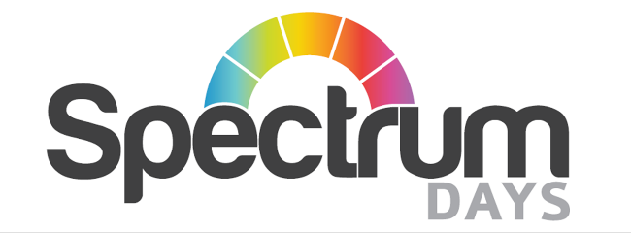

Policy on SOCIAL MEDIA AND NETWORKING

Document Details

Version 2

Date Issued October 2018
SIGNED Date 06/01/2021

Scheduled Review July 2023

Policy Statement
This policy provides guidance for employee use of social media, which should be broadly understood for purpose of this policy to include blogs, wikis, microblogs, message boards, chat rooms, electronic newsletter, online forum, social networking sites, and other sites and services that permit users to share information with others in contemporaneous manner.
The Policy
The following principles apply to the professional use of social media in this charity on behalf of this charity’s personal use of such media and includes, where relevant, the
- Employees needs to know and adhere to the Skills for Care Code of Conduct and Employee Handbook

- Employees should be aware of the effect their actions may have on their image, as well as this charity’s image. The information that employees post or publish may be public information for a long time.

- Employees should be aware that this charity may observe content and information made available by employees through social media.

- Although not an exclusive list, some specific examples of prohibited social media conduct include posting commentary, content, or images that break confidentiality, pornographic, proprietary, harassing, libellous, defamatory material, or material that can create a hostile work environment is strictly forbidden.

- Employees are not to publish, post, or release, any information that is considered confidential or not public. If there are questions about what is considered confidential, employees should check with the team leader or Service Lead.

- Social media network, blogs and other types of online content sometimes generate press and media attention or legal questions. Employees should refer these inquiries to their Service Lead or appropriate person in this charity.

- If employees find or encounter a situation while using social media that threatens to become antagonistic, employees should disengage from the dialogue in a polite manner and seek the advice of the team leader.

- Employees should get appropriate permission before they refer to or post images of current or former employees, members, vendors or suppliers. Additionally, employees should get appropriate permission to use a third party´s copyright, copyright material, trademarks, service marks or other intellectual property.

- Social media use should not interfere with the employee’s responsibilities. The computer systems are to be used for business purposes only. When using the computer system, use of social media for business purpose is allowed (e.g. Facebook, Twitter, this charity’s blogs and LinkedIn), but personal use of social media networks or personal blogging of online content is forbidden and could result in disciplinary action.

- Any online activity that violates the charity´s Code of Conduct or any other company policy may subject an employee to disciplinary action or termination of their contract.

Related policies
Adult Safeguarding
Code of Conduct for Workers
Cyber Security
Disciplinary
Training Statement
Use of social media and network is part of this charity induction. Staff are continually updated.

